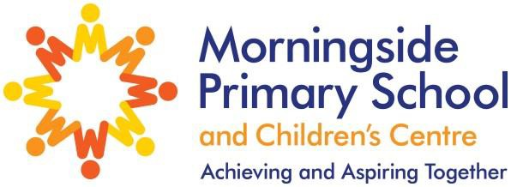

Y1 Phonic Screening Check Results 2022

Pupils meeting the expected standard
 | Passed
Morningside | 90%
National | 76%

