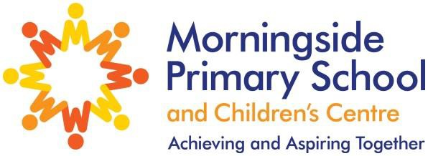
Key Stage 2 Results 2022

Pupils meeting the expected standard

 | Reading | Writing | Maths | SPaG | Combined
Morningside | 82% | 78% | 78% | 82% | 75%
Hackney | 79% | 78% | 77% | 77% | 68%
National | 74% | 69% | 71% | 72% | 59%

