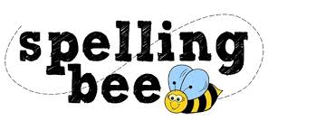
Thursday 24th November

Dear parents and carers,

We will be hosting the Morningside Spelling Bee at the end of this term.
Our teachers work hard to raise the profile of spelling and to teach the children the value of learning to spell.

Just as we celebrate sports at Sports Day we will be celebrating the efforts the children are making with their spelling.
There will be certificates for all those who take part and prizes for the winner in each year group
What will happen?
This week the children will be given a list of words to learn for their spelling competition. This will also be available on the website.

Heats will take place in class during the next few weeks.
Children do not have to enter; however, practising these spellings regularly at home may give them confidence to take part in the heats which take place in class.

Two children from each year group go through to the finals during the week beginning Monday 6th December. All children are involved in supporting their peers at this event.

DON’T

- Nag or criticize incorrect spelling. Try to find out which bit is causing the difficulty
- Spend too long on one session
- Give your child reasons to lack confidence (e.g. I was hopeless at spelling when I was at school)
DO
- Work out rules together (e.g. skate, skating drop the e when you add -ing to words ending in e)
- Be word detectives! Look for smaller words within longer ones.(e.g. football, birthday)
- Look for word families
- Break words into syllables (e.g. re-mem-ber) and affixes (e.g. dis + satisfy)
- Give lots of praise for good guesses.
- Have fun together!

How to help your child to become a spelling champion

How will spellings be tested?

During the final children will be asked to write their answers onto a whiteboard.

If there is a tie-break situation we will use words from the tie-break list that are unseen.

