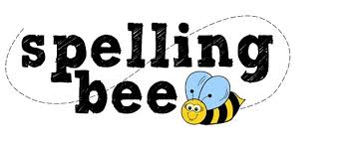

Year Six Autumn Term 2022

according | occur
curiosity | immediately
Christmas | existence
embarrass | recognise
environment | exaggerate
restaurant | dictionary
committee | criticise
competition | attached
interfere | cemetery
privilege | persuade
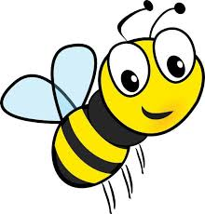Please practise these spellings if you would like to enter the Morningside Spelling Bee. Your class teacher will be running heats in your classroom.
The finals will take place on Friday 9th December. Good luck!

