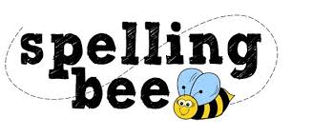

Year Five Autumn Term 2022

rhythm | temperature
sacrifice | Christmas
secretary | February
shoulder | twelfth
signature | variety
sincere | vegetable
soldier | vehicle
suggest | yacht
symbol | restaurant
system | physical
Please practise these spellings if you would like to enter the Morningside Spelling Bee. Your class teacher will be running heats in your classroom.
The finals will take place on Friday 9th December. Good luck!

