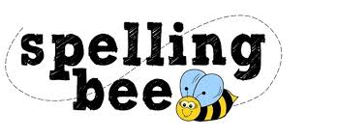

Year Four Autumn Term 2022

sentence | island
strange | height
weight | history
woman | library
various | minute
possible | February
remember | Christmas
special | particular
forwards | through
fruit | suppose
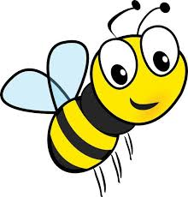Please practise these spellings if you would like to enter the Morningside Spelling Bee. Your class teacher will be running heats in your classroom.
The finals will take place on Friday 9th December. Good luck!

