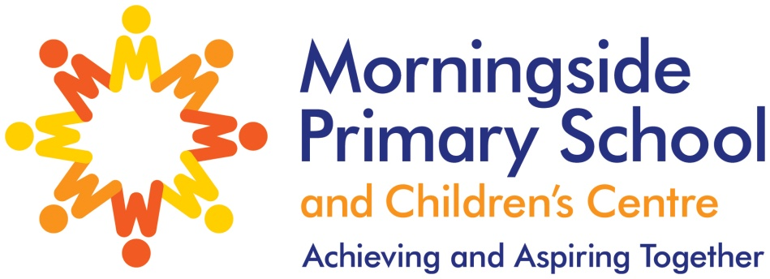
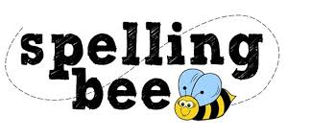

Year Three Autumn Term 2022

learn | different
library | early
length | earth
material | eight
medicine | century
naughty | believe
natural | breathe
notice | bicycle
decide | possible
describe | potatoes
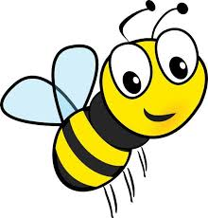Please practise these spellings if you would like to enter the Morningside Spelling Bee.
Your class teacher will be running heats in your classroom.
The finals will take place on Friday 9th December. Good luck!

