

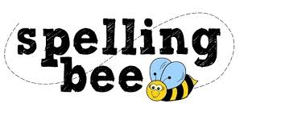

**Year One Autumn Term 2022**

|  |  |
| --- | --- |
| the | frog |
| to | cat |
| and | pig |
| we | play |
| she | door |
| he | day |
| was | went |
| shut | sing |
| flag | box |
| sheep | school |

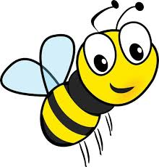 **Please practise these spellings if you would like to enter the Morningside Spelling Bee.**

**Your class teacher will be running heats in your classroom.**

**The finals will take place on Friday 9th December. Good luck!**

