

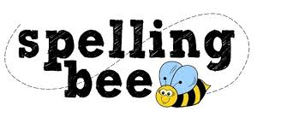

**Reception Summer Term 2022**

|  |
| --- |
| the |
| and |
| was |
| can |
| mum |
| look |
| said |
| here |
| one |
| up |
| hat |
| house |
| play |
| for |
| made |

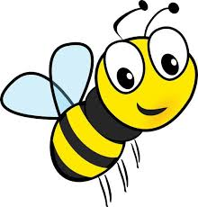 **Please practise these spellings if you would like to enter the Morningside Spelling Bee. Your class teacher will be running heats in your classroom.**

**The finals will take place on Monday 18th July. Good luck! **