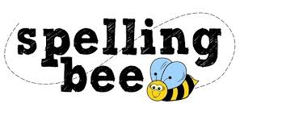

Year Five Summer Term 2022

develop | separate
dictionary | leisure
exaggerate | straight
excellent | lightning
existence | strength
explanation | marvellous
familiar | surprise
foreign | muscle
forty | necessary
frequently | although
government | neighbour
guarantee | through
harass | nuisance
identity | weight
immediate | occupy
individual | occur
interfere | opportunity
interrupt | parliament
language | persuade

Please practise these spellings if you would like to enter the Morningside Spelling Bee. Your class teacher will be running heats in your classroom.
The finals will take place on July 18th. Good luck!

