-----------
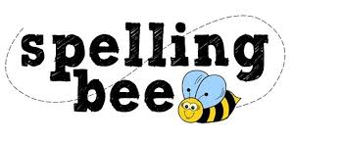

Year Four Summer Term 2022

ordinary | separate
particular | special
peculiar | straight
perhaps | strange
popular | strength
position | suppose
possible | surprise
+  potatoes | therefore
pressure | though
probably | although
promise | thought
purpose | through
quarter | various
question | weight
recent | woman
regular | women
reign | Wednesday
remember | eighty
sentence | August

Please practise these spellings if you would like to enter the Morningside Spelling Bee. Your class teacher will be running heats in your classroom.
The finals will take place on July 18th. Good luck!

