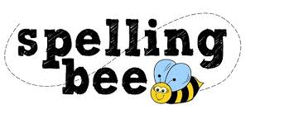

Year Three Summer Term 2022

eight | increase
enough | important
exercise | interest
experience | island
experiment | knowledge
extreme | learn
famous | length
favourite | library
February | material
forward | medicine
fruit | mention
grammar | minute
group | natural
guard | naughty
guide | notice
heard | occasionally
height | often
history | opposite
imagine | ordinary

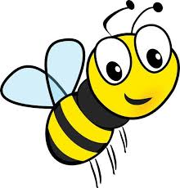 Please practise these spellings if you would like to enter the Morningside Spelling Bee. Your class teacher will be running heats in your classroom.
The finals will take place on July 18th. Good luck!

