

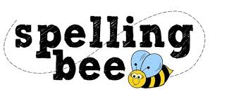

**Year One Summer Term 2022**

|  |  |
| --- | --- |
| said | some |
| shop | what |
| back | have |
| play | looked |
| very | could |
| sing | push |
| made | asked |
| about | people |

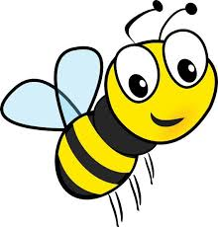**Please practise these spellings if you would like to enter the Morningside Spelling Bee. Your class teacher will be running heats in your classroom.**

**The finals will take place on July 18th. Good luck!** 