

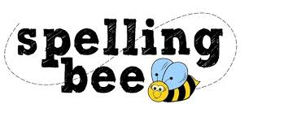

**Reception Class Autumn Term 2020**

**We hope that you will enjoy your first Morningside Spelling Bee**

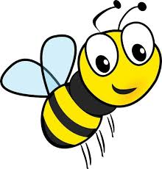

|  |
| --- |
| at |
| in |
| sad |
| it |
| sat |
| dad |
| mat |
| dog |

**Please practise these spellings if you would like to enter the Morningside Spelling Bee.**

**Your class teacher will be running heats in your classroom. There is a special certificate for everyone who takes part.**

**The finals will take place on Tuesday, 8th December. Good luck!**

