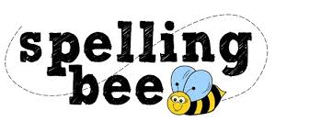

Year Six Autumn Term 2020

according | occur
curiosity | immediately
Christmas | existence
embarrass | recognise
environment | exaggerate
restaurant | dictionary
committee | criticise
competition | attached
interfere | cemetery
privilege | persuade
Please practise these spellings if you would like to enter the Morningside Spelling Bee.
Your class teacher will be running heats in your classroom. There is a special certificate for everyone who takes part.
The finals will take place on Friday 11th December. Good luck!

