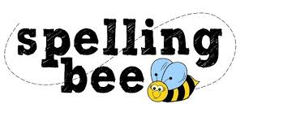

Year Five Autumn Term 2020

rhythm | temperature
sacrifice | Christmas
secretary | February
shoulder | twelfth
signature | variety
sincere | vegetable
soldier | vehicle
suggest | yacht
symbol | restaurant
system | physical
Please practise these spellings if you would like to enter the Morningside Spelling Bee.
Your class teacher will be running heats in your classroom. There is a special certificate for everyone who takes part.
The finals will take place on Friday 11th December. Good luck!

