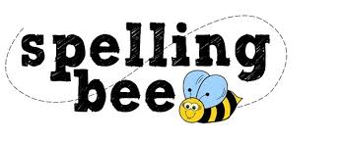

Year Four Autumn Term 2020

sentence | island
strange | height
weight | history
woman | library
various | minute
possible | February
remember | Christmas
special | particular
forwards | through
fruit | suppose
Please practise these spellings if you would like to enter the Morningside Spelling Bee.
Your class teacher will be running heats in your classroom. There is a special certificate for everyone who takes part.
The finals will take place on Friday 11th December. Good luck!

