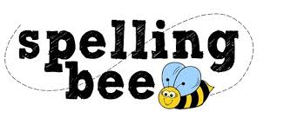

Year Three Autumn Term 2020

learn | different
library | early
length | earth
material | eight
medicine | century
naughty | believe
natural | breathe
notice | bicycle
decide | possible
describe | potatoes
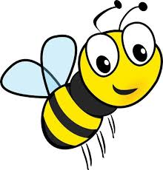 Please practise these spellings if you would like to enter the Morningside Spelling Bee.
Your class teacher will be running heats in your classroom. There is a special certificate for everyone who takes part.
The finals will take place on Friday 11th December. Good luck!

