

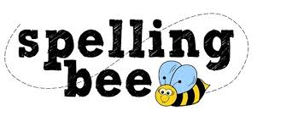

**Year Two Autumn Term 2020**

|  |  |
| --- | --- |
| floor | come |
| kind | some |
| even | Santa |
| people | money |
| poor | high |
| door | night |
| play | Saturday |
| today | happy |
| Monday | new |
| old | friend |

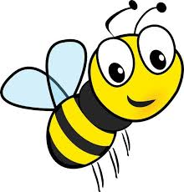 **Please practise these spellings if you would like to enter the Morningside Spelling Bee.**

**Your class teacher will be running heats in your classroom. There is a special certificate for everyone who takes part.**

**The finals will take place on Tuesday 8th December. Good luck!**