Remote Learning Policy 2020-21

- Aims
This Remote Learning Policy aims to:
- Ensure consistency in the approach to remote learning for all pupils (including SEND pupils) who are not in school, through use of quality online and offline resources
- Provide clear expectations members of the school community with regards to delivering high-quality interactive remote learning
- Align high-quality remote education as closely as possible with in-school provision.
- Ensure consistency of in-school education where staff are quarantined or self-isolating, but healthy
- Include continuous delivery of the school curriculum, as well as supporting motivation, health and well-being, and parents
- Support effective communication between the school and families and support attendance

- Who is this policy applicable to?
- All children being educated remotely during periods of National or local lockdown.
- A child (and their siblings if they are also attending Morningside Primary) who is absent because they (or a household member) are awaiting test results and the household is required to self-isolate. The rest of their school bubble are attending school and being taught as normal.
- A child whose whole bubble is not permitted to attend school because they, or another member of their bubble, have tested positive for Covid-19, as advised by PHE.
- A child who is medically advised to isolate due to being extremely vulnerable to Covid-19
- Teachers who are isolating due to a Covid-19 contact, but who are well

Remote learning will be shared with families when they are absent for Covid related reasons. Teachers who are isolating due to a Covid-19 contact will teach their class remotely.

- Curriculum
The curriculum offered by Morningside Primary School will continue to be ambitious and broad in all subjects during 2020-21. All curriculum areas have been reviewed and essential missed content from 2019-21 has been prioritised and assimilated into the 2020-21 curriculum. Due consideration has been given as to how gaps in core knowledge will be filled. In Reading, a new programme will be introduced giving children the opportunity to read a wider variety of texts. In Mathematics, a daily Maths Meeting will give children additional opportunities to practice additional areas of Maths outside the daily Maths lesson. Morningside will return to its normal curriculum in all subjects by the summer term 2021.
Pupils will be assessed, both formally and informally, at appropriate intervals to establish starting points, monitor progress and support curriculum adaptation.
- Remote Learning
Remote learning is fully integrated into the Morningside curriculum. This is outlined for each subject and year group in the appendices below. In the event of self-isolation or local/National lockdown, Morningside has the capacity to offer immediate remote education. The curriculum is carefully sequenced which facilitates the provision of high-quality online and offline resources.

5.i Content and tools to deliver remote education
Resources:
- High quality online tools for all children, Google Classroom (years 1 – 6), Google Sites (EYFS)
- Use of recorded videos and narrated PowerPoints for teaching and assemblies (asynchronous)
- Phone calls home
- Live Google Meets sessions: year group, class and small group (synchronous)
- Printed learning materials
- Physical materials such as reading books and stationery
- Use of carefully chosen school subscription sites: Times Tables Rock Stars, Numbots, Bug Club, Reading Plus, Read Write Inc, Oxford Owl, Spelling Shed

5.ii Challenges to remote learning
There are a number of challenges faced by the Morningside Community when moving to remote learning:
- It is estimated that only 25% of our families have access to a laptop or desktop computer (for each child) with reliable internet access. We have distributed our DfE allocation of Chromebooks and reconfigured a number of laptops and tablets as netbooks to give to families who have no suitable device but do have a reliable internet connection. Routers and data SIMs have been provided for families who need internet access.
- Families often have only a tablet or a phone, and/or only one device and multiple children in different years. Our families have told us that they prefer a mix of pre-recorded videos and short live sessions. This is because they can choose when is the most suitable time for a child to watch a video lesson. These can also be accessed using a smartphone.
- Where families have no internet service or device, then Morningside will provide workbooks and printed work. Teachers and pastoral staff will maintain daily contact by telephone.

6. Home-school partnership

Morningside School is committed to working in close partnership with families and recognises each family is unique and because of this remote learning will look different for different families in order to suit their individual needs.
Morningside School will provide online, telephone and in-person support for families on how to use Google Classroom and Marvellous Me as appropriate and where possible, provide personalised resources.
Where possible, it is beneficial for young people to maintain a regular and familiar routine. Morningside Primary School would recommend that each ‘school day’ maintains structure. Parents are encouraged to support their children to follow the timetable of the school day. Children have one screen-free afternoon of activities each week to promote physical activity.
We encourage parents to support their children’s work, including finding an appropriate place to work and, to the best of their ability, support pupils with work encouraging them to work with good levels of concentration.

Every effort will be made by staff to ensure that work is set promptly. Work will be available on Google Classroom at 9:00am each day. Should accessing work be an issue, parents should contact school promptly and alternative solutions may be available. These will be discussed on case-to-case basis.
All children sign an ‘Acceptable Use Policy’ at school which includes e-safety rules and this applies when children are working on computers at home.

7 Roles and responsibilities
7.i Teachers
To note: the suggested responsibilities below relate to where a local/national lockdown or where whole class/bubble is isolating and would be reduced when it is fewer children isolating and the majority of the class are in school.
Morningside School provides refresher training and induction for new staff on how to use Google Classroom, Google Sites and Marvellous Me.
When providing remote learning, teachers must be available between 8:45am and 3:45pm
If they are unable to work for any reason during this time, for example due to sickness or caring for a dependent, they should report this using the normal absence procedure.
When providing remote learning, teachers are responsible for:
Setting work:
- Teachers will set work for the pupils in their classes/year group. Year group teams can work together to provided recorded lessons but must have Google Meets/Zooms with their year group in the morning and own classes in the afternoon
- The work set should follow the usual timetable for the class had they been in school, wherever possible
- Weekly/daily work will be shared using Google Classroom (Years 1 – 6) and Google Sites (EYFS)
- Teachers will have live contact with children, using Google Meets or Zoom, each day, to provide explanations of new learning for children, unpick misconceptions, provide feedback, and teach small groups.
- Videos and high-quality curriculum resources will be available through Google Classroom and include those provided by our schemes of work e.g. White Rose Maths.
- Teachers will provide recordings of lessons using narrated Flipcharts/PowerPoints for pupils
- Teachers will adjust the pace/difficulty of work, in accordance with normal classroom practice for all children including those with SEND.
- Current medium-term plans will be annotated to show the remote learning capability for each unit of work
- Work must be saved in teacher’s planning folders with dated file names
- Where teachers are self-isolating due to Covid-19 contact, they will use the above methods to maintain the in-school teaching for their class but will additionally provide live teaching for their class using Google Meets/Zoom
- During periods of local/national lockdown: 1 teacher per year group in school teaching critical worker and vulnerable children; one teacher teaching remotely, on a one-week rota; follow the M class timetable for both classes; teaching in school follows M class timetable and usual (Covid) expectations; all planning/PowerPoints/Google Slides documents to be saved on Google Drive

Providing feedback on work:
- Reading and maths work – teachers will provide answers and feedback during the afternoon class meeting. Writing and foundation subjects- all completed work submitted by 1pm to be guaranteed teacher response and comments by 3:45pm. Comments can be typed or recorded using Mote.
- Tasks submitted by 3.30pm will be commented on by the end of the week.
Keeping in touch with pupils who are not in school and their parents:
- If there is a concern around the level of engagement teachers should inform a member of SLT who will ensure that the pupil/s parents are contacted via phone to assess whether school intervention can assist engagement. Log any issues on the Phone Log tab of the Attendance Log
- All parent/carer emails should come through the class email account (e.g. class5S@morningside.hackney.sch.uk)
- Any complaints or concerns shared by parents or pupils should be reported to a member of SLT; for any safeguarding concerns, refer immediately to the DSL using My Concern

7.ii Teaching Assistants
Teaching assistants must be available between 8:30am and 3:30pm.
If they are unable to work for any reason during this time, for example due to sickness or caring for a dependent, they should report this using the normal absence procedure.
During the school day, teaching assistants must complete tasks as directed by a member of the SLT.
They must attend the daily class Google Meets sessions.
When not in school, teaching assistants run daily interventions sessions for specific pupils over Google Meets or Zoom e.g. Jump into Reading, SaLT

7.iii Senior Leaders
Alongside any teaching responsibilities, senior leaders are responsible for:
- Co-ordinating the remote learning approach across the school including daily monitoring of engagement.
- Providing staff with the tools and resources to provide effective remote teaching, including:
- a school laptop with remote access to school systems
- login details and access to pupil accounts for all appropriate e-learning platforms
- a class email address
- training to use Google Classroom, Google Meets and any other appropriate elements of the Google Suite, e.g. Google forms for setting assessments
- training to make narrated PowerPoints into videos
- training to save flipcharts and PowerPoints in pdf form to make them easier to access remotely
- designing a comprehensive, broad, well planned, and well-resourced curriculum which sets out what is to be learned when. The curriculum maps will show what should be being learned during any period of lockdown or isolation
- recorded assemblies for remote learning
- maintain Google Drive planning systems
- Share documents using Google Drive for remote access
- Monitoring the effectiveness of remote learning – explain how they’ll do this, such as through regular meetings with teachers and subject leaders, reviewing work set or collecting feedback from pupils and parents
- Monitoring the security of remote learning systems, including data protection and safeguarding considerations
- Ensuring that the current curriculum is carefully planned and mapped throughout the year to build knowledge and skills incrementally. There is complete clarity about what is intended to be taught and practised in each subject, and when it is to be taught. This will enable a smooth transition from in-school learning to remote earning

- Supporting the class teacher with the provision of home learning for individual children who are isolating (where the class teacher is in school teaching the class).
7.iv Designated safeguarding lead
The DSL is responsible for managing and dealing with all safeguarding concerns. For further information, please see the Safeguarding and Child Protection Policy and addendum.
7.v TurnItOn IT Technicians

TurnItOn technicians are responsible for:
- Fixing issues with systems used to set and collect work
- Helping staff with any technical issues they’re experiencing
- Reviewing the security of remote learning systems and flagging any data protection breaches to the data protection officer

7.vi The SENCO
- Liaising with the TurnItOn technicians to ensure that the technology used for remote learning is accessible to all pupils and that reasonable adjustments are made where required.
- Ensuring that pupils with EHC plans continue to have their needs met while learning remotely, and liaising with the headteacher and other organisations to make any alternate arrangements for pupils with EHC plans and IHPs
- Identifying the level of support needed for children on the SEND register

7.vii The Finance and Admin Officer
- Ensuring value for money when arranging the procurement of equipment or technology.
- Ensuring that the school has adequate insurance to cover all remote working arrangements.

7.viii Pupils and parents
Staff can expect pupils learning remotely to:
- Complete work to the deadline set by teachers
- Seek help if they need it, from teachers
- Alert teachers if they’re not able to complete work
Staff can expect parents with children learning remotely to:
- Make the school aware if their child is sick or otherwise can’t complete work
- Seek help from the school if they need it
- Be respectful when making any concerns known to staff

7.ix Governing Board/Morningside LAB
The Morningside LAB is responsible for:
- Monitoring the school’s approach to providing remote learning to ensure education remains as high quality as possible
- Ensuring that staff are certain that remote learning systems are appropriately secure, for both data protection and safeguarding reasons

8 Links with other policies and development plans
This policy is linked to our:
- Safeguarding and Child Protection Policy
- Behaviour policy
- Data protection policy and privacy notices
- Online safety acceptable use policy
- Code of Conduct for Phone calls, Video conferencing and recorded video
- Agreements for Google Classroom

Appendices
Appendix 1: Learning Overview
EYFS
Nurseries | - Learning Packs to be delivered/taken home covering main curriculum areas (10 day isolation)  - Daily contact with teachers via Zoom to share news, songs and stories  - Google Sites (Rainbow and School) to share the following:  - A daily recorded pre-phonics activity  - A daily pre-recorded Maths activity
Reception | - CGP Learning Packs covering phonics, maths and writing to be delivered/taken home covering main curriculum areas. These should be annotated to show which sections to complete to match the missed in-school curriculum (10 day isolation)  - Daily contact with teachers via Zoom to share news, songs and stories  - Twice weekly small group reading lessons  - A Google Site to share the following:  - A daily recorded phonics lesson  - A daily link to an appropriate Maths lessons e.g. White Rose Maths session or Numberstacks  - Links to Oak Academy EYFS units where appropriate

KS1
Subject | Remote teaching and learning provision | Printed Resources | School Subscription sites
Reading  daily | - Daily phonics lesson recorded by teacher  - Daily story shared by teacher  - Daily RWInc reading session in small groups  - Feedback during daily meeting | Books at appropriate level | Bug Club  Oxford Owls: RWInc
Writing  4 x weekly | - Introduction from class teacher over Google Meets  - Flipcharts annotated for pupil use and shared via Google Classroom  - Annotated and narrated PowerPoints  - Children upload work to Google Classroom  - Teaching units and coverage precisely mapped  - Individual and small group feedback | Writing grids with pictures from current story stimulus/ word mats  CGP books  Spelling booklet
Maths  daily | - White Rose Maths scheme followed  - Links to daily home learning video saved in Google Classroom and on school website  - Teachers talk through learning and support children in Google Meet session  - Feedback during daily meeting  - Small group sessions | CGP books: children directed to specific sections  White Rose resources for appropriate units of work | Numbots  Times Tables Rock Stars
Science, History or Geography*  3 x weekly | - Teaching units and coverage precisely mapped  - Teacher input videos/pdfs/narrated PowerPoints saved in Google Classroom  - Children’s work and activities saved in Google Classroom  - Teacher to talk through work during Google Meet sessions  - Oak Academy sessions where appropriate  - Individual and small group feedback | Worksheets if appropriate  Knowledge organiser
Computing  weekly | - Units linked to Oak Academy |  | Coding
RE  weekly | - Teaching units and coverage precisely mapped  - Teacher input videos/pdfs/narrated PowerPoints saved in Google Classroom  - Children’s work and activities saved in Google Classroom  - Teacher to talk through work during Google Meet sessions  - Oak Academy sessions where appropriate  - Individual feedback | Worksheets if appropriate
DT*  weekly | - recorded lessons/flipchart saved weekly by the specialist teacher  - Drawing activity calendar | lessons will take into account materials that children can easily access at home
Art*
weekly
Music  weekly | - Recorded session from music teacher |  | Charanga
PE  weekly | - Teacher to introduce a fitness challenge during Google Meet session  - Monthly activity calendar  - Joe Wicks
PSHE  weekly | - Jigsaw materials saved to Google Classroom  - Weekly PSHE focused assembly  - PSHE focus Google Meet session |  | Purple Mash
* only set work for the current focus curriculum area
KS2
Subject | Remote teaching and learning provision | Printed Resources | School Subscription sites
Reading  daily | - Focus texts and extracts shared on Google Classroom  - Activity sheets shared on Google Classroom  - Teacher to outline learning and give feedback during Google Meet session  - Daily story shared by teacher  - Small group lives sessions | Reading Extracts  Comprehension Questions  Vocabulary Activity  Books at appropriate level | Bug Club  Reading Plus (Ys 5/6)
Writing  4 x weekly | - Introduction from class teacher over Google Meets  - Extracts and video prompts for writing available in Google Classroom  - Flipcharts/narrated PowerPoints annotated for pupil use and shared via Google Classroom  - Children upload work to Google Classroom  - Teaching units and coverage precisely mapped  - Individual and small group feedback  - Small group live sessions | CGP books  Writing grids with pictures from current story stimulus/ word mats  Planning jotter sheets  Spelling booklet | SPaG.com (Year 6)
Maths  daily | - White Rose Maths scheme followed  - Links to daily home learning video saved in Google Classroom and on school website  - Teachers talk through learning and support children, and give feedback in Google Meet session  - Small group live sessions | CGP books  White Rose resources for appropriate units of work | Times Tables Rock Stars  Diagnostic Questions (Ys 5/6)
Science, History or Geography*  3 x weekly | - Teaching units and coverage precisely mapped  - Teacher input videos/pdfs/narrated PowerPoints saved in Google Classroom  - Children’s work and activities saved in Google Classroom  - Teacher to talk through work during Google Meet sessions  - Oak Academy sessions where appropriate  - Individual and small group feedback | Worksheets if appropriate  Knowledge organiser
Computing  weekly | - Oak Academy sessions where appropriate |  | Coding
RE  weekly | - Teaching units and coverage precisely mapped  - Teacher input videos/pdfs/narrated PowerPoints saved in Google Classroom  - Children’s work and activities saved in Google Classroom  - Teacher to talk through work during Google Meet sessions  - Oak Academy sessions where appropriate | Worksheets if appropriate
DT*  weekly | Recorded lessons/flipchart saved weekly by the specialist teacher  Art activity calendar | lessons will take into account materials that children can easily access at home
Art*
weekly
Music  weekly | Recorded session from music teacher |  | Charanga
PE  weekly | - Teacher to introduce a fitness challenge during Google Meet session  - Monthly Activity Calendar  - Joe Wicks
PSHE  weekly | - Jigsaw materials saved to Google Classroom  - PSHE focus Google Meet session |  | Purple Mash
Spanish  weekly | - Language Angels sessions |  | Language Angels

SEND
Children with SEND will have individual learning packages. These will include signpost to specific sessions provided by Oak Academy and small group synchronous intervention sessions.

Appendix 2: Year Group Specific Remote Learning
Nurseries
Nurseries | - Learning Packs to be delivered/taken home covering main curriculum areas (10 day isolation)  - Daily contact with teachers via Zoom to share news, songs and stories  - Daily Activities on Google Sites (Rainbow and School)  - A daily recorded pre-phonics activity  - A daily pre-recorded Maths activity

2 Year Old Provision |  | 3 Year Old Provision
What to Expect When Guide
Topic | Links | Topic | Links
Me and My World | All about me, Let’s be friends, Let’s be kind, | All About Mr | Me, My family, difference, feelings, birthdays
Black History | Seasons | Animals | Babies, On the farm, habitat, rainforests, polar habitat, under the sea
Autumn | Celebrations | Autumn | Seasons
Celebrations | Christmas | In the workshop | Christmas
Christmas | Seasons | Christmas | Christmas
Transport | Transport | Winter | Seasons
Food | Food CBeebies | Food and Colour | Food CBeebies
Chinese New Year | Chinese New Year | Farm Animals | Animals
Colours (Holi) | Holi | Spring | Seasons
Spring | Seasons | Easter | Celebrations
Easter | Celebrations | Minibeasts | Our planet
Animals | Animal tea party,  Animals | Plants
Eid | Eid | Under the Sea | Under the sea
Summer | Seasons | Summer | Seasons
Me and my world | Let’s be friends, Let’s be kind, | How I have Grown | Growing up, Me

Reception
Reception | - CGP Learning Packs covering phonics, maths and writing to be delivered/taken home covering main curriculum areas. These should be annotated to show which sections to complete to match the missed in-school curriculum (10 day isolation)  - Daily contact with teachers via Zoom to share news, songs and stories  - A Google Site to share the following:  - A daily recorded phonics lesson  - A daily link to an appropriate Maths lessons e.g. White Rose Maths session or Numberblocks  - Twice weekly small group reading lessons  - Links to Oak Academy EYFS units where appropriate

Topic | Links | Literacy | Other
All about me | Me, My family, difference, feelings, birthdays |  | Music: All about me
My School Community | My friends
Autumn | Autumn, Bonfire Night
Journeys | Transport, journeys, space | Little Red Riding Hood | Music: journeys, space
Diwali | Diwali
Materials | float and sink | The Three Little Pigs
Hanukkah | Hanukkah
Christmas | Christmas Story, Christmas Traditions
Winter | Winter: Hot and cold | The King and the Moon
Animals | Babies, On the farm, habitat, rainforests, polar habitat, under the sea | Bat Learns to Dance, Little Red Hen, Three Billy Goats Gruff, Mouse, Deer and Tiger, Goldilocks and the Three Bears, Fox’s Sack | Music: habitats
Chinese New Year | Chinese new year
My Community | My community, People who help us (Drs and Nurses), People who help us (Police), People who help us (firefighters), jobs | The Noisy House | Music: Out and About
Spring | Spring | The Lucky Duck
Colour (Holi) | Holi
Easter | Easter
Plants | plants
Minibeasts | woodland
Eid | Eid
Summer | summer | The Emperor’s new clothes
Country Study
Food and Growing | healthy eating | The Sweet Talking Potato, The Giant Turnip, The Gingerbread man | Music: growth
How I have Grown | transitions

Year 1 remote learning overview
Single child isolating
Paper provision pack suitable for Year 1
Work provided on Google Classroom by SLT

Teacher isolating due to contact
Teach over Google Meets – stick to class timetable where possible

General provision
- Logins sheet (with all logins and website addresses)
- Homework book for recording work and stationery pack
- reading book and home reading record; books can be changed weekly
- Morning Google Meet to go through provision and problem solve, daily subject focus and story
- Afternoon Google Meet for feedback and answers
- Live small group reading and Maths sessions
- work offered follows school timetable
Subject | Home Provision
Maths | - Links to videos and resources uploaded to Google Classroom/website  - Children to upload completed work to Google Classroom or record in homework book  - Numbots and Times Tables Rock Stars  - CGP books with specific links and/or printed WRM sheets
Reading | - Reading book and home reading record  - Oxford Owl and Bug Club  - Daily story time: live link to class story time + recording of the session  - Virtual Book corner  - Daily synchronous small group reading lesson  - CGP books with specific links  - Phonics: daily phonics session – recorded using format of in-school lesson  - BBC Bitesize - Phonics
Spelling | - Spelling lists – set by teacher in Spelling Shed to follow pattern of RWInc spelling programme  - Spelling Shed  - BBC Bitesize – Spelling
Writing | - Narrated PowerPoints using school-based units  - Links to video/PowerPoint stimuli for writing  - Children can record work in homework book or Google Classroom  - CGP books with specific links  - BBC Bitesize
Topic | - Knowledge organiser sent home (see links below)  - Links to Oak Academy where appropriate or BBC Bitesize – Science skills  - Resources posted to Google Classroom  - Narrated PowerPoints – can use resources such as PlanBee/Twinkl to create these  - Children can record work in homework book or Google Classroom
Spanish | - Word of the week posted on school website
Music | - Resources posted on Charanga  - Narrated/video Charanga lesson from music teacher weekly  - Oak Academy
Computing | Code Spark Academy
RE | - Links to Oak Academy where appropriate: Oak Academy  - Resources posted to Google Classroom  - Narrated PowerPoints – can use resources such as PlanBee/Twinkl to create these  - Children can record work in homework book or Google Classroom
PSHE | - Narrated Jigsaw-based PowerPoint  - Google Meet PSHE focus session  - Oak Academy
Art/DT | - weekly recorded lesson from specialist teacher
PE | - Teacher to introduce a fitness challenge during Google Meet session  - Monthly Activity Calendar  - Joe Wicks

Topic |  | Writing
Subject Area | Links | Subject Area | Links
Materials | Materials  unit pack  BBC Bitesize | traditional tales
London | London  unit pack  BBC Bitesize | recount | Diary entry
My History | Changes is living memory  toys unit pack  transport unit pack | repeating patterns
Animals | The Animal Kingdom  knowledge organiser  unit pack  BBC Bitesize | instructions | How to make a paper crown (2.5 weeks)
Seasons (inc. light) | Seasons and Change  knowledge organiser A&W  Knowledge organiser S&S  unit pack A&W  unit pack S&S | traditional tales | Monkeys and Hats  Monkeys and Hats 2
Amy Johnson and Bessie Coleman | Bessie Coleman Fact file | instructions
Australia |  | fairy tales | Jack and the Beanstalk
Plants | Plants  knowledge organiser  unit pack  BBC Bitesize | author focus | The Magic Paintbrush  The Magic Paintbrush 2
Animals | The Animal Kingdom  knowledge organiser  unit pack  BBC Bitesize | traditional tales | Anansi and Tiger (2.5 weeks)
Weather | unit pack  BBC Bitesize | instructions
Florence Nightingale and Mary Seacole | knowledge organiser  unit pack  BBC Bitesize | predictable phrases | Honey and Trouble  Honey and Trouble 2
 |  | traditional tales | Awongalema  Awongalema 2
 |  | predictable phrases | How butterflies came to be
 |  | children’s experiences

Year 2 remote learning overview
Single child isolating
Paper provision pack suitable for Year 2
Work provided on Google Classroom by SLT

Teacher isolating due to contact
Teach over Google Meets – stick to class timetable where possible

General provision
- Logins sheet (with all logins and website addresses)
- Homework book for recording work and stationery pack
- reading book and home reading record; books can be changed weekly
- Morning Google Meet to go through provision and problem solve, daily subject focus and story
- Afternoon Google Meet for feedback and answers
- Live small group reading and Maths sessions
- work offered follows school timetable
Subject | Home Provision
Maths | - Links to videos and resources uploaded to Google Classroom/website  - Children to upload completed work to Google Classroom or record in homework book  - Numbots and Times Tables Rock Stars  - CGP books with specific links and/or printed WRM sheets
Reading | - Reading book and home reading record  - Oxford Owl and Bug Club  - Daily story time: live link to class story time + recording of the session  - Virtual Book corner  - Extracts and questions posted on Google Classroom when Year 2 move to Whole Class Reading  - Daily synchronous small group reading lesson  - CGP books with specific links  - Phonics: daily phonics session – recorded using format of in-school lesson  - BBC Bitesize - Phonics
Spelling | - Spelling lists – set by teacher in Spelling Shed to follow pattern of RWInc spelling programme  - Spelling Shed
Writing | - Narrated PowerPoints using school-based units  - Links to video/PowerPoint stimuli for writing  - Children can record work in homework book or Google Classroom  - CGP books with specific links
Topic | - Knowledge organiser sent home (see links below)  - Links to Oak Academy where appropriate or BBC Bitesize – Science skills  - Resources posted to Google Classroom  - Narrated PowerPoints – can use resources such as PlanBee/Twinkl to create these  - Children can record work in homework book or Google Classroom
Spanish | - Word of the week posted on school website
Music | - Resources posted on Charanga  - Narrated/video Charanga lesson from music teacher weekly  - Oak Academy
Computing | Code Spark Academy
RE | - Links to Oak Academy where appropriate: Oak Academy  - Resources posted to Google Classroom  - Narrated PowerPoints – can use resources such as PlanBee/Twinkl to create these  - Children can record work in homework book or Google Classroom
PSHE | - Narrated Jigsaw-based PowerPoint  - Google Meet PSHE focus session  - Oak Academy
Art/DT | - weekly recorded lesson from specialist teacher
PE | - Teacher to introduce a fitness challenge during Google Meet session  - Monthly Activity Calendar  - Joe Wicks

Topic |  | Writing
Subject Area | Links | Subject Area | Links
plants | knowledge organiser  unit pack  BBC Bitesize | traditional tales | How Coyote brought fire to the Earth (1)  How Coyote brought fire to the Earth (2)  Ganesh gets married (1)  Ganesh gets married (2)
Kenya | Plan Bee units – saved on system  Continents  knowledge organiser  unit pack | instructions | How to defeat the fire giants
Great Fire of London | Great Fire of London  knowledge organiser  unit pack | recurring language | Baba Yaga (1)  Baba Yaga (2)
Materials | Changing Materials  Building Things  knowledge organiser  unit plan  BBC Bitesize | instructions
Animals | Human Lifestyle  knowledge organiser  unit plan  BBC Bitesize
India – city v country | Villages, Towns and Cities  unit plan | recount | news report
Space Race | knowledge organiser | explanation | How birds fly
Habitats | Habitats  knowledge organiser  unit plan  BBC Bitesize | author focus
Hackney | Changes in Living Memory  Our Local Area  Magical Mapping | instructions
 |  | stories about a theme | The bird and the forest fire (1)  The bird and the forest fire (2)
 |  | myths | Persephone (endings)  Persephone (2)
 |  | strong characters | The Eagle who thought he was a chicken (1)  The Eagle who thought he was a chicken (2)  The Unlucky Man
 |  | Non-chronological report | All about witches

Year 3 remote learning overview
Single child isolating
Paper provision pack suitable for Year 3
Work provided on Google Classroom by SLT

Teacher isolating due to contact
Teach over Google Meets – stick to class timetable where possible

General provision
- Logins sheet (with all logins and website addresses)
- Homework book for recording work and stationery pack
- reading book and home reading record; books can be changed weekly
- Morning Google Meet to go through provision and problem solve, daily subject focus and story
- Afternoon Google Meet for feedback and answers
- Live small group reading and Maths sessions
- work offered follows school timetable
Subject | Home Provision
Maths | - Links to videos and resources uploaded to Google Classroom/website  - Children to upload completed work to Google Classroom or record in homework book  - Numbots and Times Tables Rock Stars  - CGP books with specific links and/or printed WRM sheets
Reading | - Reading book and home reading record  - Bug Club  - Daily story time: live link to class story time + recording of the session  - Virtual Book corner  - Extracts and questions posted on Google Classroom, narrated PowerPoints  - Small group synchronous reading lessons  - CGP books with specific links  - Oak Academy units: Into the Forest, Mulan, The Firework Maker’s Daughter, King of the Sky, Rushing Rivers, The Suitcase Kid
Spelling | - Spelling lists – set by teacher in Spelling Shed to follow pattern of RWInc spelling programme  - Oak Academy
SPaG | - Oak Academy
Writing | - Narrated PowerPoints using school-based units  - Links to video/PowerPoint stimuli for writing  - Children can record work in homework book or Google Classroom  - CGP books with specific links
Topic | - Knowledge organiser sent home (see links below)  - Links to Oak Academy where appropriate and BBC Bitesize  - Resources posted to Google Classroom  - Narrated PowerPoints – can use resources such as PlanBee/Twinkl to create these  - Children can record work in homework book or Google Classroom
Spanish | - Word of the week posted on school website
Music | - Resources posted on Charanga  - Narrated/video Charanga lesson from music teacher weekly  - Oak Academy
Computing | Code Spark Academy
RE | - Links to Oak Academy where appropriate:  - Resources posted to Google Classroom  - Narrated PowerPoints – can use resources such as PlanBee/Twinkl to create these  - Children can record work in homework book or Google Classroom
PSHE | - Narrated Jigsaw-based PowerPoint  - Google Meet PSHE focus session
Art/DT | - weekly recorded lesson from specialist teacher  - Art activity calendar
PE | - Teacher to introduce a fitness challenge during Google Meet session  - Monthly Activity Calendar  - Joe Wicks

Topic |  | Writing
Subject Area | Links | Subject Area | Links
plants | Plants  Knowledge Organiser  Unit Pack  BBC Bitesize | Fables
Benin | Knowledge Organiser  Unit Pack | Instructions | Monster Pizza (2.5 weeks)
Light | Light and dark  Knowledge Organiser  Unit Pack  BBC Bitesize | Non-chronological report | Portia Spiders (5 weeks)
Animals | Knowledge Organiser  Unit Pack  BBC Bitesize | Fairy Tales | The Man on the Moon (4 weeks)
The UK | United Kingdom  Weather  Knowledge Organiser  Unit Pack  BBC Bitesize  BBC Bitesize - maps | Explanation | How Bees make Honey (4 weeks)
Forces | Magnetism  Knowledge Organiser  Unit Pack  BBC Bitesize | Alternative Fairy Tales | The Fate of Fausto
The Ages | Prehistoric Britain  Knowledge Organiser  Unit Pack  BBC Stone Age  BBC Bronze Age  BBC Iron Age | Author Focus | The BFG (5 weeks)
Spain | Europe  Use Plan Bee resources saved on system  BBC Bitesize – settlement | Non-chronological report
Sutton House |  | Traditional Tales
Rocks | Rock Cycle  Knowledge Organiser  Unit Pack | Persuasion | Healthy Food (2.5 weeks)
 |  | Recount | Journey (5 weeks)
 |  | Adventure Stories
 |  | Recount
 |  | Traditional Tales | Aladdin (5 weeks)
 |  | Persuasion | The Day the Crayons Quit (4 weeks)
 |  | Instructions

Year 4 remote learning overview
Single child isolating
Paper provision pack suitable for Year 4
Work provided on Google Classroom by SLT

Teacher isolating due to contact
Teach over Google Meets – stick to class timetable where possible

General provision
- Logins sheet (with all logins and website addresses)
- Homework book for recording work and stationery pack
- reading book and home reading record; books can be changed weekly
- Morning Google Meet to go through provision and problem solve, daily subject focus and story
- Afternoon Google Meet for feedback and answers
- Live small group reading and Maths sessions
- work offered follows school timetable
Subject | Home Provision
Maths | - Links to videos and resources uploaded to Google Classroom/website  - Children to upload completed work to Google Classroom or record in homework book  - Times Tables Rock Stars  - CGP books with specific links and/or printed WRM sheets
Reading | - Reading book and home reading record  - Bug Club  - Daily story time: live link to class story time + recording of the session  - Virtual Book corner  - Extracts and questions posted on Google Classroom, narrated PowerPoints  - Small group synchronous reading lessons  - CGP books with specific links  - Oak Academy units: There’s a boy in the girls’ bathroom, Hansel and Gretel, I was a rat, Hidden Depths: Exploring the deep, Walter Tull’s Scrapbook, A Christmas Carol
Spelling | - Spelling lists – set by teacher in Spelling Shed to follow pattern of RWInc spelling programme  - Oak Academy
SPaG | - Oak Academy
Writing | - Narrated PowerPoints using school-based units  - Links to video/PowerPoint stimuli for writing  - Children can record work in homework book or Google Classroom  - CGP books with specific links
Topic | - Knowledge organiser sent home (see links below)  - Links to Oak Academy where appropriate  - Resources posted to Google Classroom  - Narrated PowerPoints – can use resources such as PlanBee/Twinkl to create these  - Children can record work in homework book or Google Classroom
Spanish | - Word of the week posted on school website
Music | - Resources posted on Charanga  - Narrated/video Charanga lesson from music teacher weekly  - Oak Academy
Computing | Code Park Academy
RE | - Links to Oak Academy where appropriate:  - Resources posted to Google Classroom  - Narrated PowerPoints – can use resources such as PlanBee/Twinkl to create these  - Children can record work in homework book or Google Classroom
PSHE | - Narrated Jigsaw-based PowerPoint  - Google Meet PSHE focus session  - Oak Academy
Art/DT | - weekly recorded lesson from specialist teacher  - Art activity calendar
PE | - Teacher to introduce a fitness challenge during Google Meet session  - Monthly Activity Calendar  - Joe Wicks

Topic |  | Writing
Subject Area | Links | Subject Area | Links
Plants | Plants  Knowledge Organiser  Unit Pack | Imaginary Settings
Indus Valley | Knowledge Organiser  BBC Bitesize | Persuasion
Habitats/animals | Human anatomy  Humans Knowledge Organiser  Humans Unit Pack  Habitats knowledge organiser  Habitats Unit Pack  BBC Bitesize | Stories with a theme | The Robin (5 weeks)
Extreme Earth | Mountains, Volcanoes and Earthquakes  Knowledge Organiser  Unit Pack  BBC Bitesize Mountains  BBC Bitesize Earthquakes  BBC Bitesize Volcanoes | Non-chronological reports | Angler Fish (5 weeks)
Electricity | Electrical Circuits  Knowledge Organiser  Unit Pack  BBC Bitesize | Playscripts | Poetry (5 weeks)
Sound | Sound  Knowledge Organiser  Unit Pack  BBC Bitesize | Discussion
Romans | Roman Britain  Knowledge Organiser  Unit Pack  BBC Bitesize | Non-fiction
States of Matter | States of Matter  Knowledge Organiser  Unit Pack  BBC Bitesize | Author Focus | The Borrowers (4 weeks)
WW2 | Knowledge Organiser  Unit Pack | Myth | The Jabberwocky (5 weeks)
Jamaica | Knowledge Organiser | Explanation | Chocolate Making (5 weeks)
 |  | Issues and dilemmas | Whale Rider (4 weeks)
 |  | Recount
 |  | Persuasion
 |  | Traditional Tales | Journalistic Writing (5 weeks)

Year 5 remote learning overview
Single child isolating
Paper provision pack suitable for Year 5
Work provided on Google Classroom by SLT

Teacher isolating due to contact
Teach over Google Meets – stick to class timetable where possible

General provision
- Logins sheet (with all logins and website addresses)
- Homework book for recording work and stationery pack
- reading book and home reading record; books can be changed weekly
- Morning Google Meet to go through provision and problem solve, daily subject focus and story
- Afternoon Google Meet for feedback and answers
- Live small group reading and Maths sessions
- work offered follows school timetable
Subject | Home Provision
Maths | - Links to videos and resources uploaded to Google Classroom/website  - Children to upload completed work to Google Classroom or record in homework book  - Diagnostic Questions and Times Tables Rock Stars  - CGP books with specific links and/or printed WRM sheets
Reading | - Reading book and home reading record  - Bug Club and Reading Plus  - Daily story time: live link to class story time + recording of the session  - Virtual Book corner  - Extracts and questions posted on Google Classroom, narrated PowerPoints  - Small group synchronous reading lessons  - CGP books with specific links  - Oak Academy units: Mary Anning by K Barnham, The British by B Zephaniah, Demon Dentist by D Walliams, Poetry – de la Mare and Poe, Streetchild by Berlie Doherty, Mirror by Jeannie Baker
Spelling | - Spelling lists – set by teacher in Spelling Shed to follow pattern of RWInc spelling programme  - Oak Academy
SPaG | - Oak Academy
Writing | - Narrated PowerPoints using school-based units  - Links to video/PowerPoint stimuli for writing  - Children can record work in homework book or Google Classroom  - CGP books with specific links
Topic | - Knowledge organiser sent home (see links below)  - Links to Oak Academy where appropriate  - Resources posted to Google Classroom  - Narrated PowerPoints – can use resources such as PlanBee/Twinkl to create these  - Children can record work in homework book or Google Classroom
Spanish | - Word of the week posted on school website
Music | - Resources posted on Charanga  - Narrated/video Charanga lesson from music teacher weekly
Computing | - Oak Academy  - Code Spark Academy
RE | - Links to Oak Academy where appropriate:  - Resources posted to Google Classroom  - Narrated PowerPoints – can use resources such as PlanBee/Twinkl to create these  - Children can record work in homework book or Google Classroom
PSHE | - Narrated Jigsaw-based PowerPoint  - Google Meet PSHE focus session  - Oak Academy
Art/DT | - weekly recorded lesson from specialist teacher
PE | - Teacher to introduce a fitness challenge during Google Meet session  - Monthly Activity Calendar  - Joe Wicks

Topic |  | Writing
Subject Area | Links | Subject Area | Links
Forces | Forces  Knowledge Organiser  Unit Pack  BBC Bitesize | Biography
Windrush | Resource Pack | Literary Heritage Fiction | Oliver Twist (8 weeks)
Human Development/Lifecycles | Reproductive Cycles  Knowledge Organiser  Unit Pack  Lifecycles Unit Pack  Lifecycles KO  BBC Bitesize | Explanation | Contained in How to Train Your Dragon
Brazil | Biomes  South America  Knowledge Organiser  BBC Bitesize | Chronological Report | Inspirational Figures (2 weeks)
Materials | Separating Mixtures  Physical and Chemical Changes  Knowledge Organiser  Unit Pack  BBC Bitesize | Narrative viewpoint | The Viewer
Anglo-Saxons | Knowledge Organiser  Unit Pack  BBC Bitesize | Non-chronological report-comparison | Wild Cats
Earth in Space | Space  Knowledge Organiser  Unit Pack  BBC Bitesize | Persuasion | School Uniform (2.5 weeks)
Ancient Greece | Ancient Greece  Knowledge Organiser  Unit Pack  BBC Bitesize | Suspense and Mystery | The Highway Man (6 weeks)
 |  | Explanation
 |  | Legends | How to Train your Dragon (10 weeks)
 |  | Flashbacks | Macbeth (5 weeks)
 |  | Persuasion | Contained in How to Train Your Dragon
 |  | Chronological Report
 |  | Comparative Report

Year 6 remote learning overview
Single child isolating
Paper provision pack suitable for Year 6
Work provided on Google Classroom by SLT

Teacher isolating due to contact
Teach over Google Meets – stick to class timetable where possible

General provision
- Logins sheet (with all logins and website addresses)
- Homework book for recording work and stationery pack
- reading book and home reading record; books can be changed weekly
- Morning Google Meet to go through provision and problem solve, daily subject focus and story
- Afternoon Google Meet for feedback and answers
- Live small group reading and Maths sessions
- work offered follows school timetable
Subject | Home Provision
Maths | - Links to videos and resources uploaded to Google Classroom/website  - Children to upload completed work to Google Classroom or record in homework book  - Numbots and Times Tables Rock Stars  - CGP books with specific links and/or printed WRM sheets  - Times Tables Rock Stars, Diagnostic Questions
Reading | - Reading book and home reading record  - Bug Club and Reading Plus  - Daily story time: live link to class story time + recording of the session  - Virtual Book corner  - Extracts and questions posted on Google Classroom, narrated PowerPoints  - CGP books with specific links  - Oak Academy units: The Giant’s Necklace, Holes, The Blitz Survivor, The Greenling, London is the Place for Me, Goodnight Mr Tom, A Career in Computer Games
Spelling | - Spelling lists – set by teacher in Spelling Shed to follow pattern of RWInc spelling programme  - Oak Academy Spelling lessons
SPaG | - Oak Academy SPaG lessons
Writing | - Narrated PowerPoints using school-based units  - Links to video/PowerPoint stimuli for writing  - Children can record work in homework book or Google Classroom  - CGP books with specific links
Topic | - Knowledge organiser sent home (see links below)  - Links to Oak Academy where appropriate  - Resources posted to Google Classroom  - Narrated PowerPoints – can use resources such as PlanBee/Twinkl to create these  - Children can record work in homework book or Google Classroom
Spanish | - Word of the week posted on school website
Music | - Resources posted on Charanga  - Narrated/video Charanga lesson from music teacher weekly  - Oak Academy
Computing | - Oak Academy
RE | - Links to Oak Academy where appropriate: Oak Academy  - Resources posted to Google Classroom  - Narrated PowerPoints – can use resources such as PlanBee/Twinkl to create these  - Children can record work in homework book or Google Classroom
PSHE | - Narrated Jigsaw-based PowerPoint  - Google Meet PSHE focus session  - Oak Academy
Art/DT | - weekly recorded lesson from specialist teacher  - art activity calendar
PE | - Teacher to introduce a fitness challenge during Google Meet session  - Monthly Activity Calendar  - Joe Wicks
Topic |  |  | Writing
school |  | home | school | home
electricity |  | Knowledge organiser  Oak Academy Electrical Circuits  Unit Pack  BBC Bitesize | biography/autobiography | Nelson Mandela life story  Oak Academy biography unit (2 weeks)
Empire |  | Oak Academy Population  BBC Bitesize - trade | Chronological Report | Windrush Diary Writing  (5 weeks)
Light |  | Oak Academy Light  Knowledge organiser  Unit Pack  BBC Bitesize | Fictional Genres | Sherlock Holmes (6 weeks)
Evolution & Inheritance |  | Oak Academy Humans and animals over time  Knowledge Organiser  Unit Pack  BBC Bitesize | Explanation
Animals |  | Oak Academy Diet and Lifestyle  Knowledge Organiser  Unit Pack  BBC Bitesize | Persuasion | contained within Sherlock Holmes unit
Classification |  | Knowledge Organiser  Unit Pack | Discussion
Anglo Saxons & Vikings |  | Knowledge Organiser  Unit Pack  BBC Bitesize Vikings | Non-Fiction multi-genre | contained within journalistic writing unit
Burberry |  | Oak Academy Globalisation | Author Focus | The Golden Compass
 |  |  | Non-Chronological report | Pandas (3 weeks)
 |  |  | Non-Fiction workshop | Journalistic writing (4 weeks)
 |  |  | Narrative workshop | Rabbit Proof Fence (2 weeks)
 |  |  | Debating Skills

Appendix 3: Timetables
Year 1 Year 2
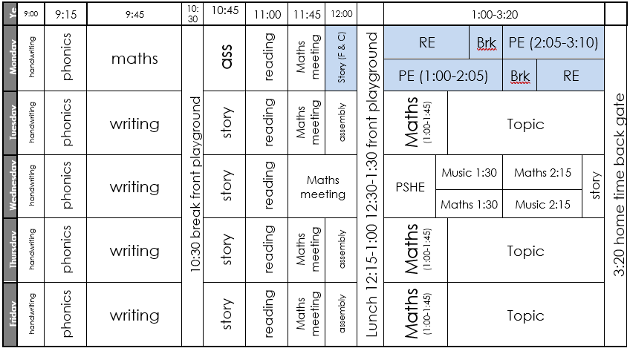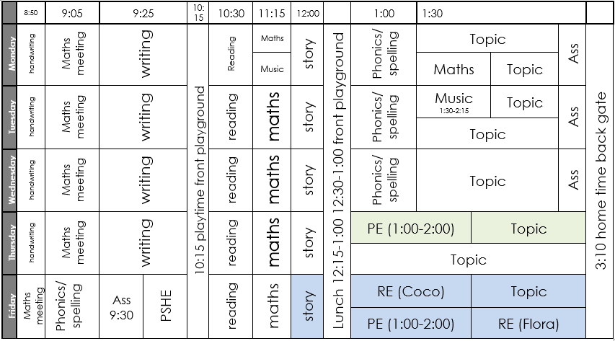
Year 3 Year 4
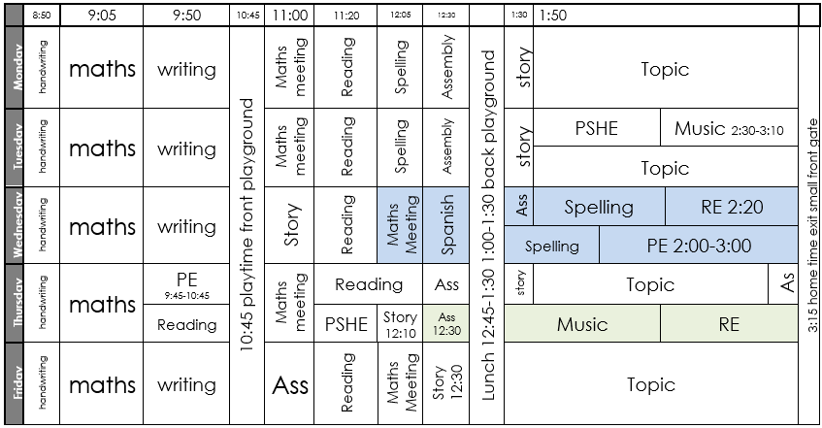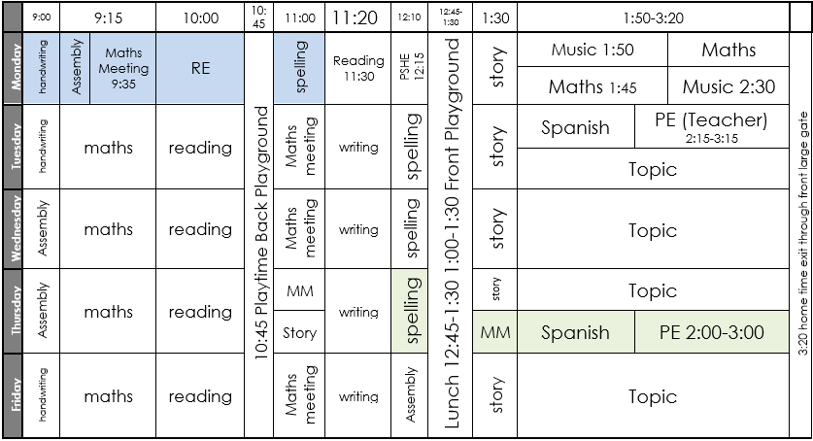
Year 5 Year 6
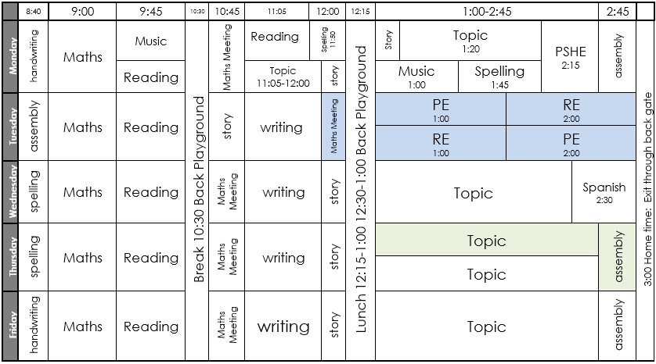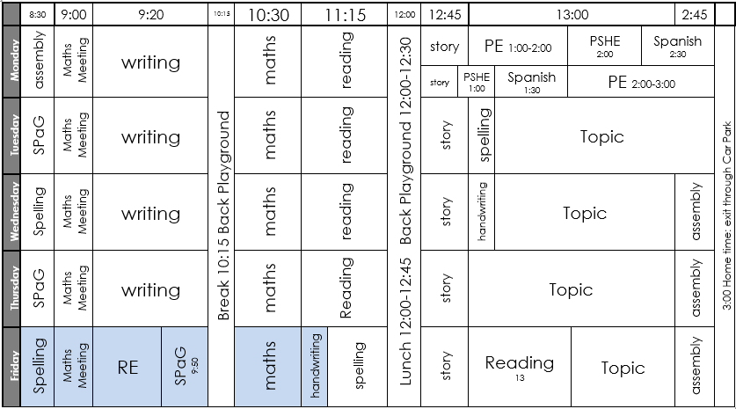
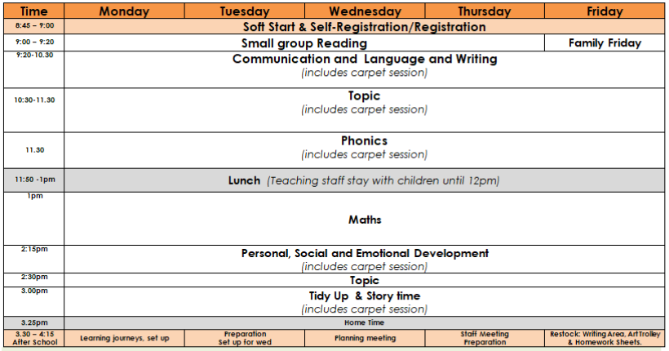
Reception Nursery
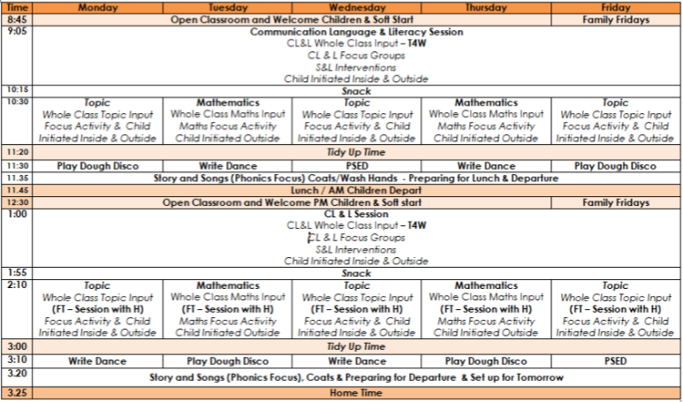

Appendix 4: Guide to making a narrated PowerPoint
You can also record narrated Flipcharts/PowerPoints in Zoom – see below
- Make a normal PowerPoint with all your lesson materials. You can use animations and transitions if you wish, but simpler is usually better.

- Click on the Slide Show tab
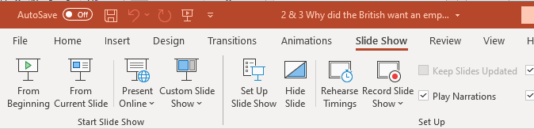

- Click on the arrow under Record Slide Show and choose the Record from the Beginning option
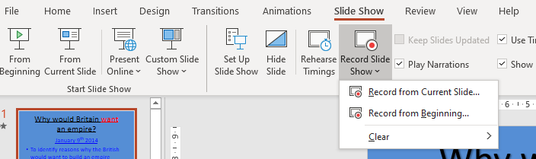

- You will see a screen like this; you should be at the bottom right. There are tools to annotate the PowerPoint under the main slide. 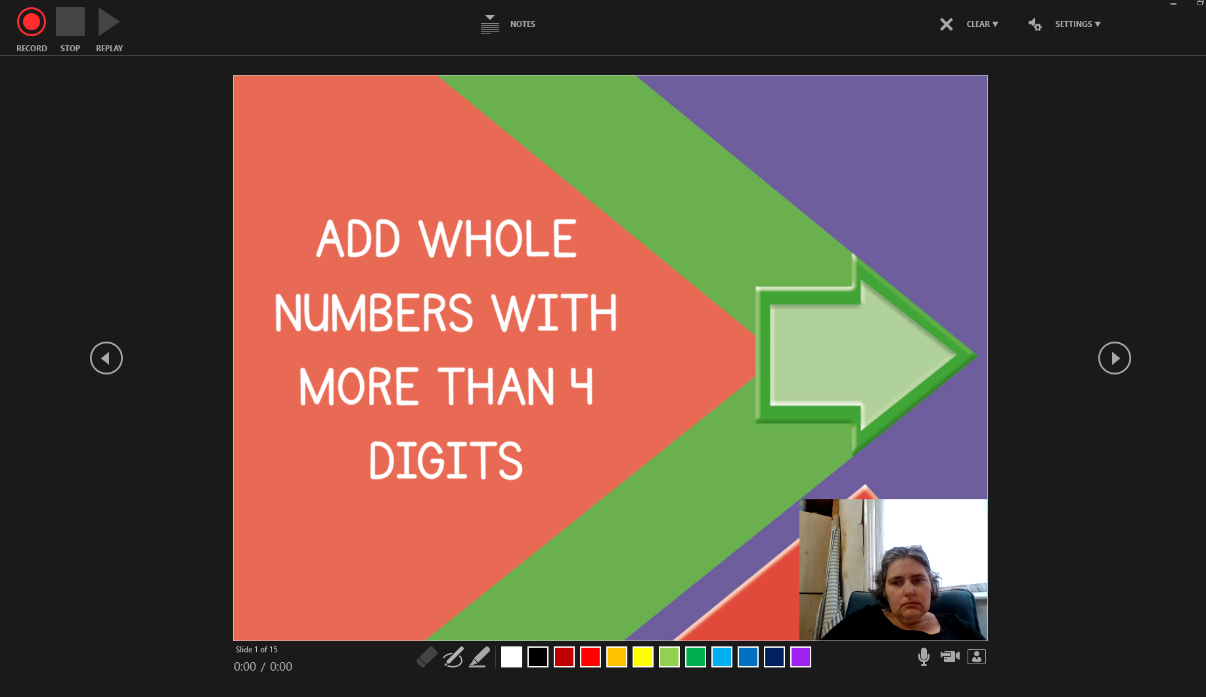

- Press the red record button in the top left-hand corner.
- Click on each slide as you normally would to bring up different sections of each slide. Talk about each slide and explain what is being learnt just as you would do in a lesson. Annotate using the tools. Avoid placing content in the bottom right-hand corner.

- Move onto the next slide by clicking the right arrow.

- Click stop when you have finished recording.
- Watch it back to check that you are happy with it.

- You can rerecord individual slides; choose Record from Current Slide

- Save the PowerPoint as usual.

- Then save the PowerPoint as a video using the options below. This can take quite a while.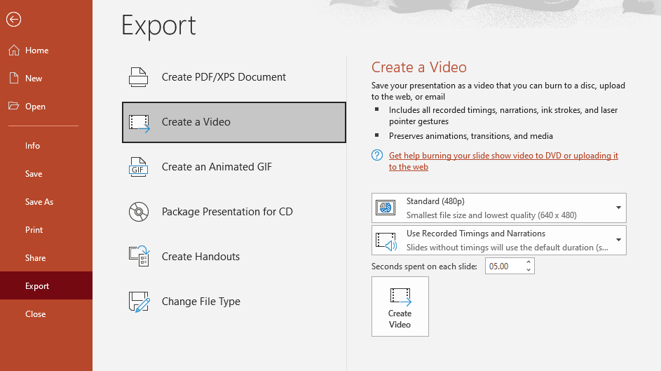

Other recording software
Zoom – start a meeting with yourself and record. Start recording after you have shared your screen.
It is easier to use Google Slides with Google Classroom. The simplest way to record these is using Zoom.
1. Start a Zoom meeting on your own.
2. Share your screen and ensure that you are happy with what you can see – there is a pointer in Google Slides that you can use to highlight parts of the screen.
3. Use the menu at the top of the screen to start recording.
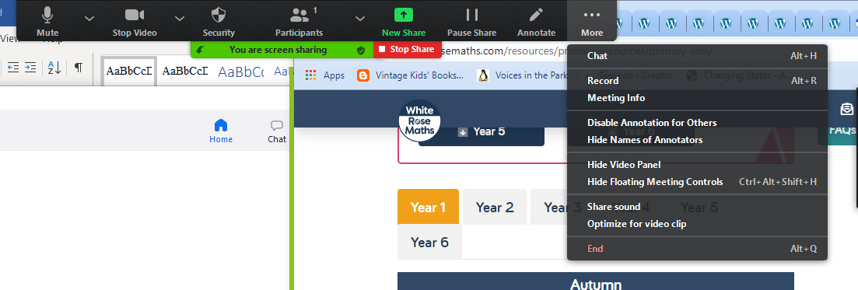

4. Don’t worry about being perfect! Rehearse what you are going to say before you record it and try to do it first take.
5. Use the menu at the top of the screen to stop recording before you stop sharing your screen.
6. Stop the screen share
7. End the meeting.
8. Zoom will save a copy of the video which you can then upload.

Loom – this can be used as a Google Chrome extension and works well when recording Google Slides. It has basic editing features.

Appendix 5: Setting work on Google Classroom
- Make sure that you are in the Classwork section
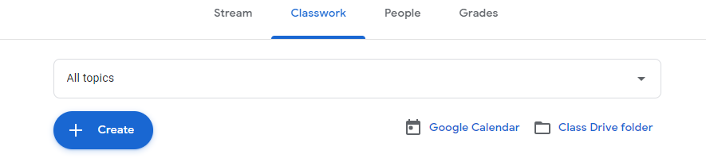
- Use the Create button to choose what to add.
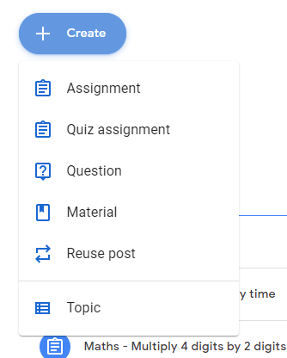 See below for a guide to the different options.

- First create a new topic. Work should be saved in a folder for each day e.g. Friday 02.10.20. So create a new topic for each day. Use the format dd.mm.yy

- In any work created you should include the following:

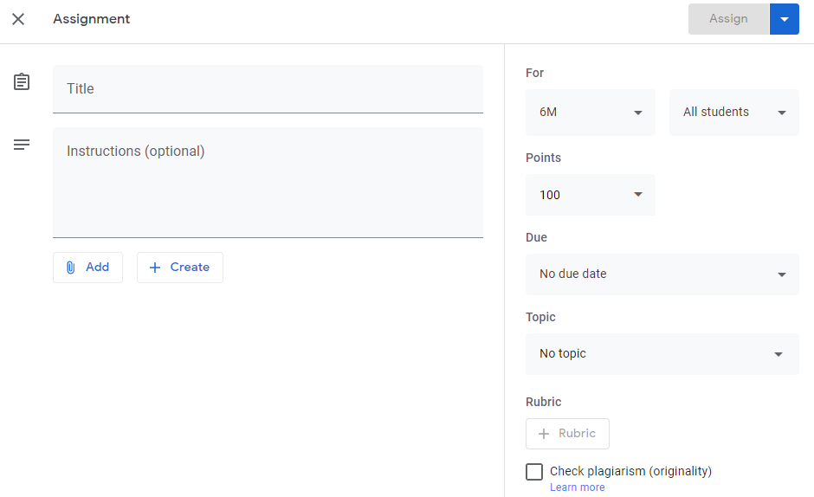
Clear instructions – include any weblinks here
Explain how work can be handed in

Clear title: subject + brief detail

- If you are setting work for both classes in your year group – you can choose multiple classes by clicking the arrow here:
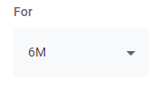This will bring up a list of all the classes to choose from.

- Click the arrow next to all students to set work for specific children; this will support differentiation.
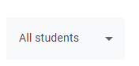

- Set the points to ungraded or to a specific number if it is something like an arithmetic test.
- Set a due date for the next door or the next day you have that subject
- Set the topic to the dated folder you have created for that day’s work
- Use the add button to add files:
- Use the create button to create forms and documents that the children can type directly onto:
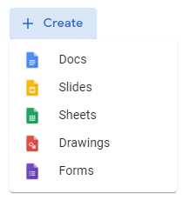
- Once you have created a document then select ‘make a copy for each student’. This will give each child their own copy to work on

- When you are ready to assign the work, you can assign it straight away if it is work for that day. If the work is for a day in the future, then schedule the assignment using the arrow next to the assign button and select schedule.
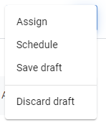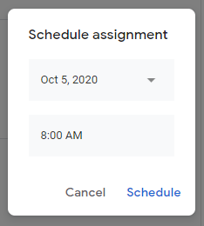
Choose the date and time you wish to schedule the work for.

- Different types of work to create
Choose one of the following categories for the work you assign.
assignment – a general category that you can attach documents to. This is the most useful category
quiz assignment – has a form automatically attached which you can use to collect answers. You can also input the correct answers to turn this into a self-marking quiz. The first question on the form needs to be ‘name’ or you won’t know whose work is whose. You access the answer sheets by clicking on the 9 dots symbol and selecting forms.
question – this is used to ask one short answer or multiple-choice question to the group. Switch off the ability for children to respond to each other. You can still add documents and create docs to support this.
material – this is useful for posting information that is not work e.g. your class timetable
reuse post – this lets you reuse a post that you have already posted elsewhere

- Giving feedback
In the grades tab, you will see a table of all the children and task set. You will see what has been turned in (it will either say turned in or _/100). Click on the 3 vertical dots to the right (these will appear when you hover over them) and then click on view submission. You will then be able to comment on the work in the private comments section.
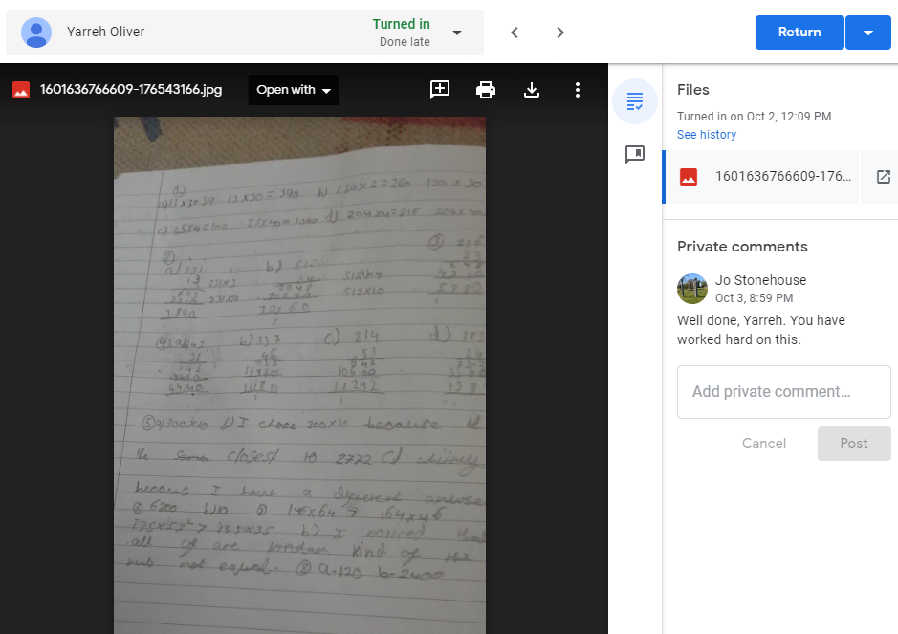
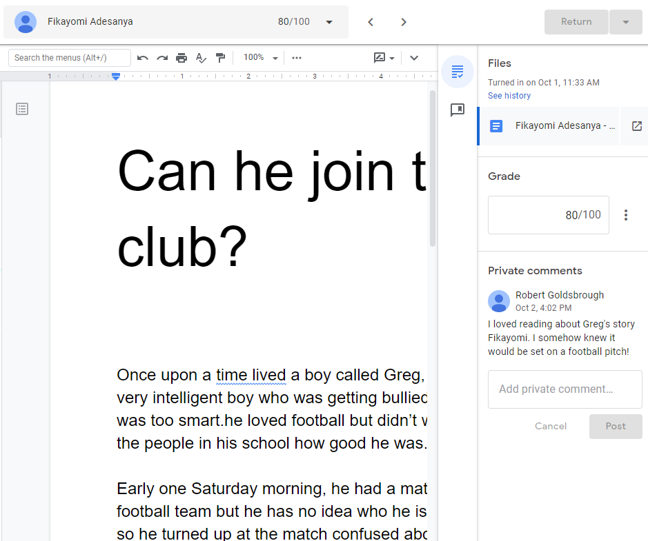
- Hosting a meeting
Scheduling and hosting the meeting:
- Send a Marvellous Me and post a message in the stream for both classes, between 1 hour and 30 minutes before the meeting to remind families that the meeting is going to happen.
- To schedule the same meeting for both classes in a year group, the ‘remote learning’ teacher should generate a Meet Link in their setting page (ensure that this is NOT visible to students). Then share the link with the children using the stream for each class. You should schedule the message so that it becomes visible at the start time of the meeting. You MUST be ‘in’ the meeting before the children, there is no waiting room. After the meeting, delete the meeting link from the stream as the links remain live even after the meeting is over. Make sure that all children leave the meeting before you close it. You can keep using the same link for each meeting.

- The message in the stream should say: Here is the link for today’s morning/afternoon meeting: link address. Just click on the link to start the meeting. The meeting will start at x time and end at x time.

- The meetings should be open for 30 minutes. Children do not have to stay online for the whole time if you have already shared everything with them. The family may need the device for another child to attend a different meeting.

- During the meeting ask all children to mute their microphones: ensure that you have seen each child with their video switched on. You can ask children to unmute if they need to speak.

- Ensure that all children are not eating or drinking and are appropriately dressed.

- Take a register using the Google Sheet provided; this will be monitored by the pastoral team. Using the Google extension will support you to take the register

- Any child who has not attended the morning session, must receive a phone call after the meeting. SIM cards will be provided for class teachers to use to do this; withhold your private number. If there is any family that cannot be contacted, please refer them to the Pastoral team. If the family are having difficulty with accessing the meetings due to Wi-Fi or hardware issues, please let the pastoral team know as soon as possible.

- The class teacher and children in school should attend the morning Google Meet.

- Meetings must be recorded by the host teacher.

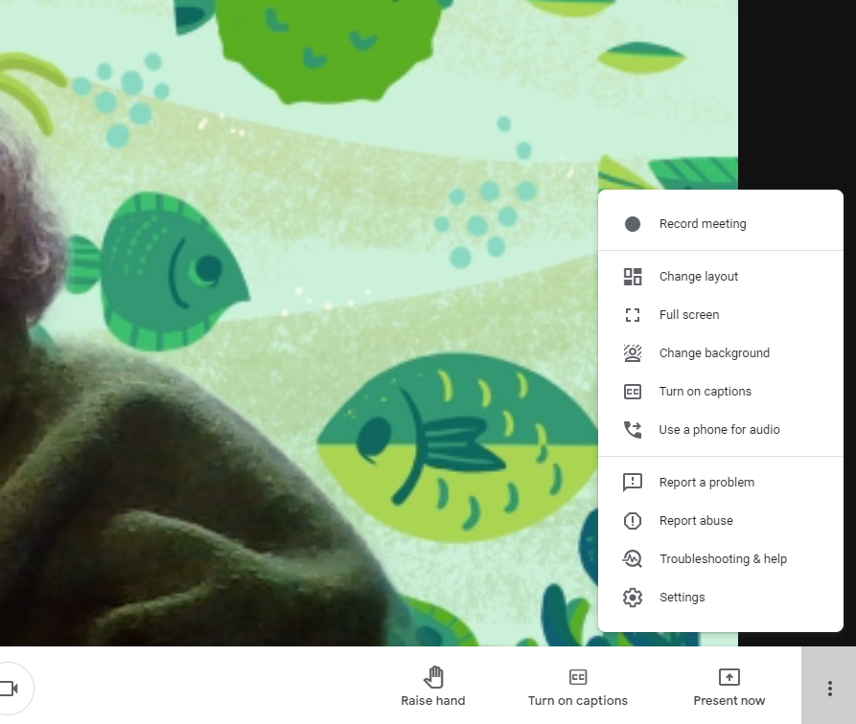
Once in the meeting, click on the three vertical dots in the bottom righthand corner and then select record meeting from the top of the menu. A recording of the meeting will be emailed to you automatically.

You can also change your background here.

The change layout option allows you to organise how many people you can see on your call at one time. You can view up to 49 people at once.

Meeting Focus

 | Morning | Afternoon
Daily | Go through work set and answer any questions | Feedback: answers to Maths and Reading comprehension  Revisit focus so that more children can contribute.
Monday | Stars of the Week | feedback and revisit focus
Tuesday | Book Club – children to bring and share the book that they are reading | feedback and revisit focus
Wednesday | Wellbeing and fitness  Share activity calendars | feedback and revisit focus
Thursday | Arts and Crafts – share any pictures or things you have made | feedback and revisit focus
Friday | Book Club – children to bring and share the book that they are reading | feedback and revisit focus

Addendum
Leave the meeting link up for the duration of the meeting - some children will join after their siblings have been to their class meetings which overlap yours.
Meeting links: Please make sure you use the meeting link generated in settings not the one you can see when you start the meeting. It will look like this and must have the word ‘lookup’ in it: 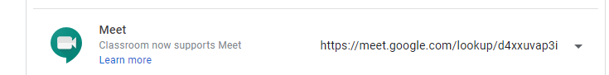

This link contains the code to the meeting automatically and should not require children to input an additional code. If anyone is asking for the code in the stream, then this is the gobbledigook after the final /.

- Supporting your pupils to complete and hand in work
They need to look on the classworks stream to find their work, then click on the piece of work they are going to do and then on view assignment at the bottom:
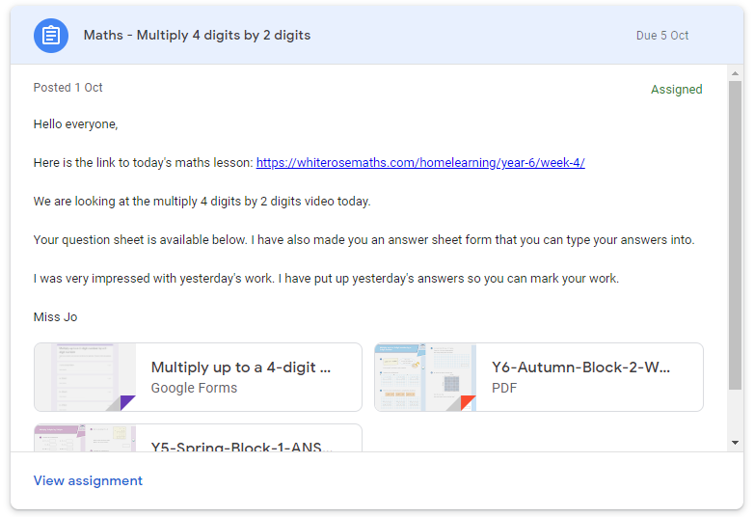
They should then open the documents to view the work. To complete the work they can work on paper and photograph it and upload the photo, work in a document that has been created for them or use ‘add or create’ to make their own document to work in.
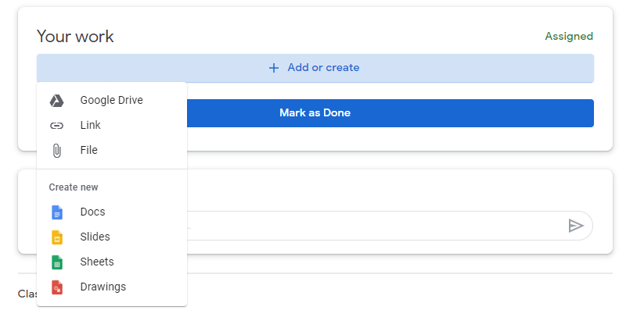
If they are working in a Google Doc then they must click ‘turn in’ when they have completed their work.

They should then click ‘Hand in’ on the assignment screen.
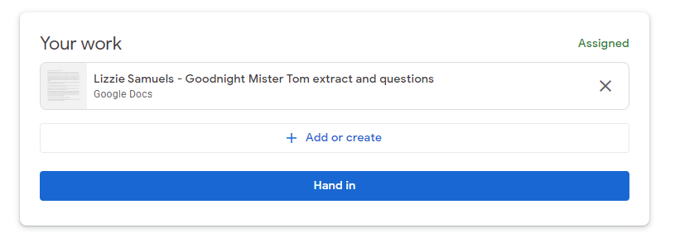
and again here:
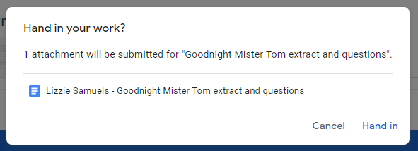

If they are uploading their work, then they should click ‘mark as done’ when it has been uploaded. They should also click this if they have done their work but cannot upload it so that you know they have completed it.
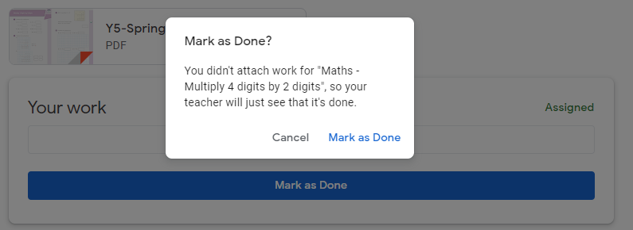

Children can also complete their work in their homework book and bring this to the afternoon meeting/small group sessions.

Appendix 6: Google Sites (EYFS)
A Google Site is a basic website design tool. This is used to share daily learning videos and resources for EYFS children and families.
A good guide to using the product can be found here: https://support.google.com/sites/answer/6372878?hl=en
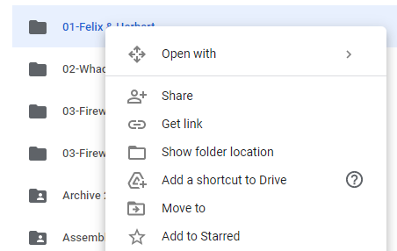
All content shared on the site must have the permissions set to everyone can view.
Choose share

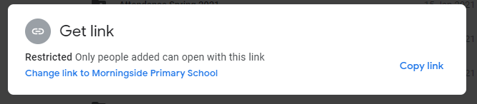
Select ‘change link to Morningside Primary School’

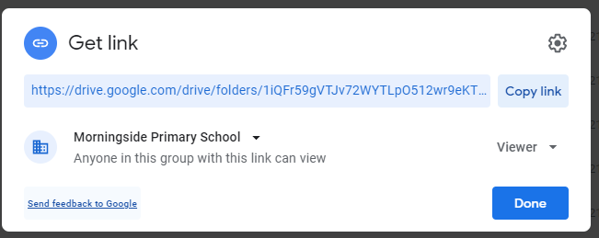
Click the small arrow to the right of Morningside Primary School

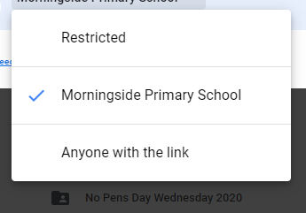
Select ‘Anyone with the link’

Appendix 7: Useful Extensions and Maths Resource Sites
Zoom scheduler – adds Zoom to your calendar and makes it easier to set meetings
Grammarly – online grammar checker
Loom – screen recording – convert to an educators’ account for free
Emoji keyboard
Bitmoji – add your Bitmoji to Google Classroom
Mote – leave recorded feedback for children
Jamboard – on screen whiteboard (included in G-Suite)

Maths manipulatives
Maths Bot
Math Learning Centre
Toy Theatre

